Estimation of energy performance of residential buildings

Revision Number: 1.0

Last date of revision: 23/06/2021

# Document Version Control

|  |  |  |  |
| --- | --- | --- | --- |
| Date Issued | Version | Description | Author |
| 13/06/2021 | 1 | Initial HLD — V1.0 | Mayur Rathod |
|  |  |  |  |
|  |  |  |  |
|  |  |  |  |
|  |  |  |  |
|  |  |  |  |

## Contents

Document Version Control. 2

Abstract. 4

1. Introduction 5
   1. Why this High-Level Design Document?. 5
   2. Scope. 5
   3. Definitions 5
2. General Description. 6
   1. Product Perspective 6
   2. Problem statement 6
   3. PROPOSED SOLUTION 6
   4. FURTHER IMPROVEMENTS 6
   5. Technical Requirements. 6
   6. Data Requirements 7
   7. Tools used. 8
   8. Constraints 9
   9. Assumptions. 9
3. Design Details 10
   1. Process Flow. 10
      1. Model Training and Evaluation 10
      2. Deployment Process 11
   2. Event log 11
   3. Error Handling 11
   4. Performance. 12
   5. Reusability. 12
   6. Application Compatibility 12
   7. Resource Utilization 12
   8. Deployment. 12
4. Dashboards. 13
   1. KPIs (Key Performance Indicators) 13
5. Conclusion 14

Abstract

When designing and building a new energy-efficient house, and it can be a challenge. However,

recent technological improvements in building elements and construction techniques also allow most modern energy saving ideas to be seamlessly integrated into house designs while improving comfort, health, or aesthetics. And even though some energy-efficient features are expensive, there are others that many home buyers can afford. While design costs, options, and styles vary, most energy-efficient homes have some basic elements in common: a well constructed and tightly sealed thermal envelope; controlled ventilation; properly sized, high-efficiency heating and cooling

systems; and energy-efficient doors, windows, and appliances.

1. **Introduction**

###### Why this High-Level Design Document?

The purpose of this High-Level Design (HLD) Document is to add the necessary detail to the current project description to represent a suitable model for coding. This document is also intended to help detect contradictions prior to coding, and can be used as a reference manual for how the modules interact at a high level.

The HLD will:

* + - Present all of the design aspects and define them in detail
    - Describe the user interface being implemented
    - Describe the performance requirements
    - Include design features and the architecture of the project
    - List and describe the non-functional attributes like: o Security
      * Reliability
      * Maintainability
      * Portability
      * Reusability
      * Application compatibility
      * Resource utilization
      * Serviceability

##### Scope

The HLD documentation presents the structure of the system, such as the database architecture, application architecture (layers), application flow (Navigation), and technology architecture. The HLD uses non-technical to mildly-technical terms which should be understandable to the administrators of the system.

* 1. **Definitions**



*Term*

*Database*

*IDE AWS*

*Description*

Collection of all the information monitored by this system

Integrated Development Environment

Amazon Web Services

### General Description

#### Product Perspective

The energy efficiency analysis for different shapes is a machine learning-based regressor model which will help us to predict the value of heating load and cooling load .

* 1. **Problem statement**

To create a web-application interface to estimate heating and cooling load.

* + - To use a number of classical and non-parametric statistical analytic tools to carefully analyze the strength of each input variable's correlation with each of the output variables.
    - To compare a traditional linear regression approach to a sophisticated state-of-the-art nonlinear non-parametric method, random forests.
  1. PROPOSED SOLUTION

The solution proposed here is to implemented a number of classical and non-parametric statistical analytic tools to carefully analyse the strength of each input variable's correlation with each of the output variables in order to discover the most strongly associated input variables to perform above mention use cases.

* 1. FURTHER IMPROVEMENTS

More feature attribute can be added in dataset to get more accurate results in real time.

#### Technical Requirements

This document addresses the requirements for detecting the anomalies in the society at early stages and recommending the necessary and rapid action to avoid imbalance in the harmony of the society. Mobile platforms like Ground robots should be used for this purpose. Ground Robots can be based on wheels, tracks, or legs.

* + - UGV should be able to move on steps and various terrains. Wheel robots or Wheel-Legged robots would better fit kind of tasks.
    - These UGVs’ should include many sensors like stereo vision cameras, panoramic camera, thermal and infrared detecting systems.
    - These can be battery powered or solar powered.
    - UGVs’ should be equipped with proper computing power to process the images or video of anomalies it had detected.

#### Data Requirements

We get data from [this](https://archive.ics.uci.edu/ml/datasets/energy+efficiency) link.

This is our project for continuous dataset. The dataset is of Energy efficiency for building. We will be using Python as our programming language.

Our project perform energy analysis using 12 different building shapes simulated in Ecotect. The buildings differ with respect to the glazing area, the glazing area distribution, and the orientation, amongst other parameters. The dataset comprises 768 samples and 8 features. Our aim to predict two real valued responses.

The dataset contains eight attributes and two responses.

X1=Relative Compactness

X2=Surface Area

X3=Wall Area

X4=Roof Area

X5=Overall Height

X6=Orientation

X7=Glazing Area

X8=Glazing Area Distribution

Y1=Heating Load

Y2=Cooling Load

* 1. Tools used

Python programming language and frameworks such as NumPy, Pandas, Scikit-learn, and flask are used to build the whole model.





 

* + - PyCharm is used as IDE.
    - For visualization of the plots, Matplotlib, Seaborn and Plotly are used.
    - Pandas and NumPy use for training model and statistical aspects.
    - Heroku is used for deployment of the model.
    - HTML, CSS, and JavaScript are the languages used for Front End development.
    - Python flask is used for backend development.
    - GitHub is used as version control system.

#### Constraints

The Interface for energy efficiency estimation of residential buildings must be user friendly, as automated as possible and users should not be required to know any of the workings.

#### Assumptions

The main objective of the project is to implement the use cases as previously mentioned (2.2 Problem Statement) for new dataset that comes through user inputs. Machine Learning model is used for detecting the above-mentioned use cases based on the input data. It is also assumed that all aspects of this project have the ability to work together in the way the designer is expecting.

## Design Details

##### Process Flow

For identifying the different types of attributes, we will use a deep learning base model. Below is the process flow diagram is as shown below.

##### Proposed methodology

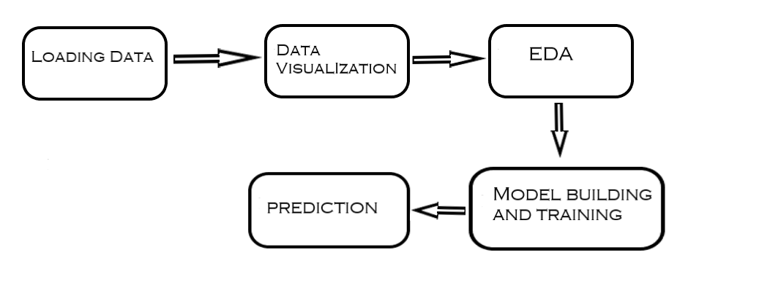

##### Model Training and Evaluation

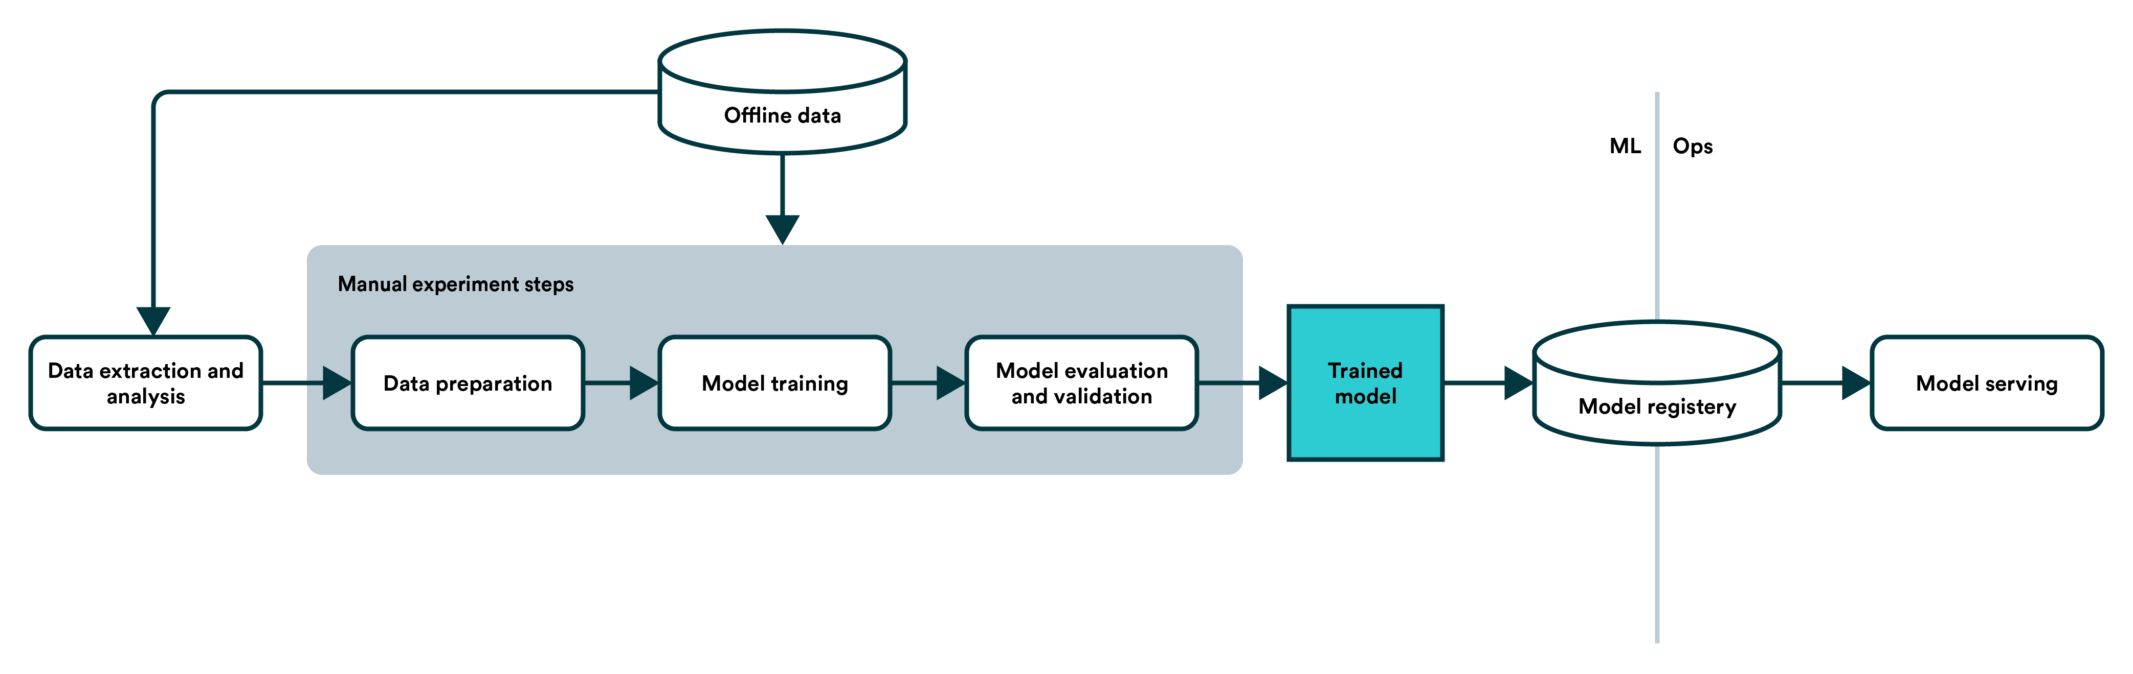

##### Deployment Process

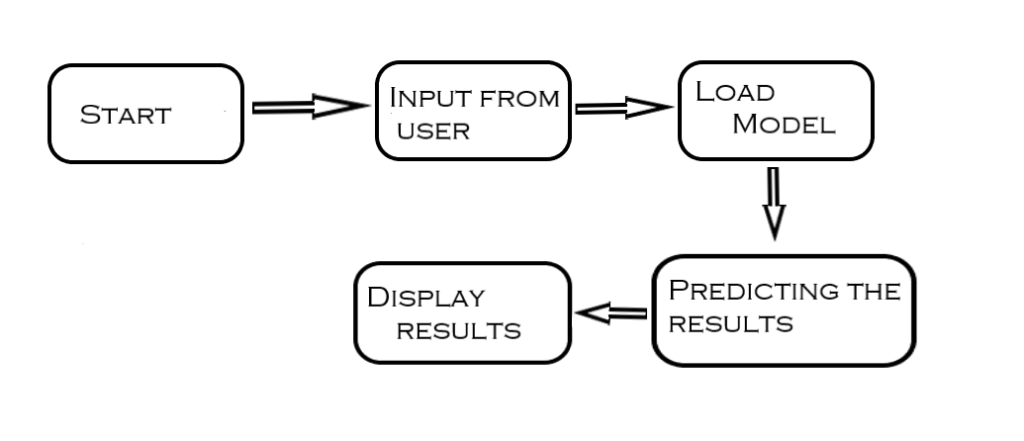

* 1. Event log

The system should log every event so that the user will know what process is running internally.

Initial Step-By-Step Description:

1. The System identifies at what step logging required
2. The System should be able to log each and every system flow.
3. Developer can choose logging method. You can choose database logging/ File logging as well.
4. System should not hang even after using so many loggings. Logging just because we can easily debug issues so logging is mandatory to do.
   1. **Error Handling**

Should errors be encountered, an explanation will be displayed as to what went wrong? An error will be defined as anything that falls outside the normal and intended usage.

1. Performance

The energy efficiency estimation of residential buildings is used for detection of heating and cooling load values for different building shapes, so it should be as accurate as possible. So that it will not mislead the concern authorities. Also, model retraining is very important to improve the performance.

#### Reusability

The code written and the components used should have the ability to be reused with no problems.

#### Application Compatibility

The different components for this project will be using Python as an interface between them. Each component will have its own task to perform, and it is the job of the Python to ensure proper transfer of information.

#### Resource Utilization

When any task is performed, it will likely use all the processing power available until that function is finished.

* 1. **Deployment**





## Dashboards

Dashboards will be implemented to display and indicate certain KPls and relevant indicators for the unveiled problems that if not addressed in time could cause catastrophes of unimaginable impact.



As and when, the system starts to capture the historical/periodic data for a user, the dashboards will be included to display charts over time with progress on various indicators or factors.

#### KPls (Key Performance Indicators)

1. Key indicators displaying a summary of the anomaly detection in the society/area.
2. Time and workload reduction using the UGV based surveillance.
3. To detect mob (illegal) activities and inform police.
4. On time alert to nearest hospital on medical emergency (accident).
5. Taking adequate evidence of mob.
6. Send disaster details to concerned authorities.
7. Display of battery life and percentage of UGV.
8. Distance travelled by UGV.
9. Get the exact location of UGV.

## Conclusion

The solution of energy efficiency estimation of residential buildings is implemented using number of classical and non-parametric statistical analytic tools to carefully analyze the strength of each input variable's correlation with each of the output variables in order to discover the most strongly associated input variables to perform modeling.

By using important feature attributes and training models we can find out accurate heating load and cooling load values for different housing shapes. so we can have a pleasant and energy efficient environment in our housing area or location.

## References

1. https://en.wikipedia.org/wiki/Unmanned ground vehicle
2. Google.com for images of UGV hardware.
3. [https://www.ros.org/](http://www.ros.org/)